Nama | : Hafied Mustaman
NBI | : 1461700138
Kelas | : D9
Praktikum | : Dasar Pemrograman
Tugas Akhir Praktikum | : 2 | ACC DOSBIM | ACC ASLAB

- Program sederhana menggunakan for, do … while, dan while
  - for
/* Perulangan For */
#include <iostream>
#include <conio.h>
using namespace std;
int main()
{
int bil1, bil2, bil3;
cout<<"======================================"<<endl;
cout<<"1. Menampilkan deret angka 0 sampai 10"<<endl;
cout<<"======================================"<<endl<<endl;
for(bil1=0; bil1<=10; bil1++)
{
cout<<bil1<<" ";
}
cout<<endl<<endl;
cout<<"============================================"<<endl;
cout<<"2. Menampilkan deret angka genap 2 sampai 10"<<endl;
cout<<"============================================"<<endl<<endl;
for(bil2=2; bil2<=10; bil2++)
{
bil2%2==0;
cout<<bil2<<" ";
bil2++;
}
cout<<endl<<endl;
cout<<"============================================"<<endl;
cout<<"3. Menampilkan deret angka ganjil 1 sampai 9"<<endl;
cout<<"============================================"<<endl<<endl;
for(bil3=0; bil3<10; bil3++)
{
bil3%2!=0;
cout<<bil3+1<<" ";
bil3++;
}
cout<<endl;
getch();
}

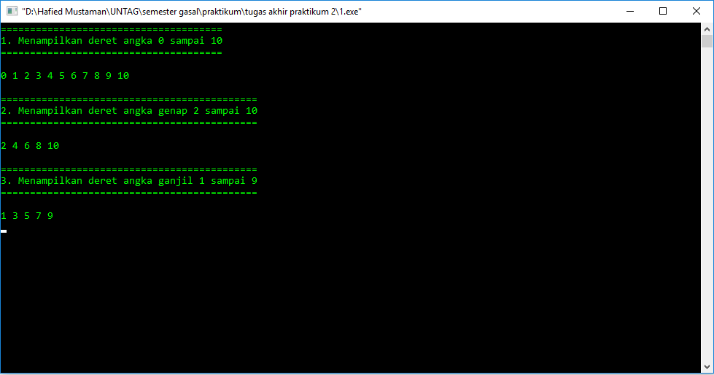

  - do … while
/* Perulangan Do While */
#include <iostream>
#include <conio.h>
using namespace std;
int main()
{
int bil1=0, bil2=0, bil3=0;
cout<<"======================================"<<endl;
cout<<"1. Menampilkan deret angka 0 sampai 10"<<endl;
cout<<"======================================"<<endl<<endl;
do
{
cout<<bil1<<" ";
bil1++;
}
while(bil1<=10);
cout<<endl<<endl;
cout<<"============================================"<<endl;
cout<<"2. Menampilkan deret angka genap 2 sampai 10"<<endl;
cout<<"============================================"<<endl<<endl;
do
{
bil2=bil2+2;
cout<<bil2<<" ";
}
while(bil2<=8);
cout<<endl<<endl;
cout<<"============================================"<<endl;
cout<<"3. Menampilkan deret angka ganjil 1 sampai 9"<<endl;
cout<<"============================================"<<endl<<endl;
do
{
bil3=bil3+1;
cout<<bil3<<" ";
bil3++;
}
while(bil3<=9);
cout<<endl;
getch();
}
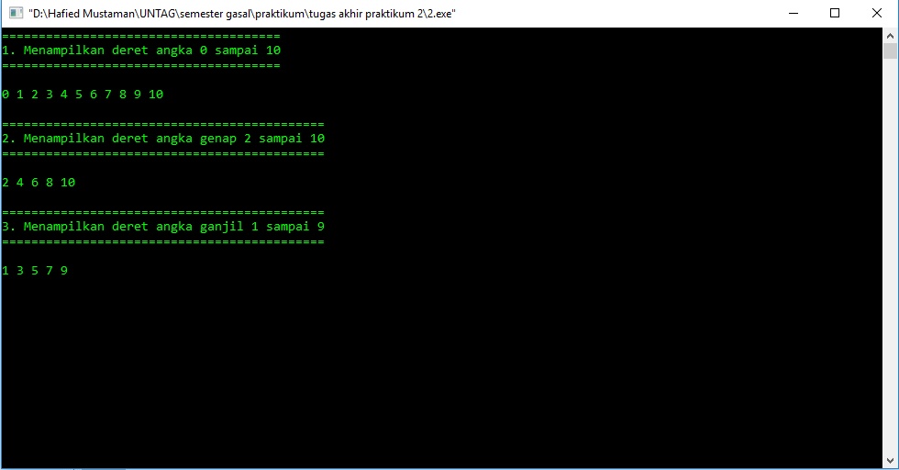

  - while
/* Perulangan While */
#include <iostream>
#include <conio.h>
using namespace std;
int main()
{
int bil1=0, bil2=0, bil3=0;
cout<<"======================================"<<endl;
cout<<"1. Menampilkan deret angka 0 sampai 10"<<endl;
cout<<"======================================"<<endl<<endl;
while(bil1<=10)
{
cout<<bil1<<" ";
bil1++;
}
cout<<endl<<endl;
cout<<"============================================"<<endl;
cout<<"2. Menampilkan deret angka genap 2 sampai 10"<<endl;
cout<<"============================================"<<endl<<endl;
while(bil2<=8)
{
bil2=bil2+2;
cout<<bil2<<" ";
}
cout<<endl<<endl;
cout<<"============================================"<<endl;
cout<<"3. Menampilkan deret angka ganjil 1 sampai 9"<<endl;
cout<<"============================================"<<endl<<endl;
while(bil3<=9)
{
bil3=bil3+1;
cout<<bil3<<" ";
bil3++;
}
cout<<endl;
getch();
}
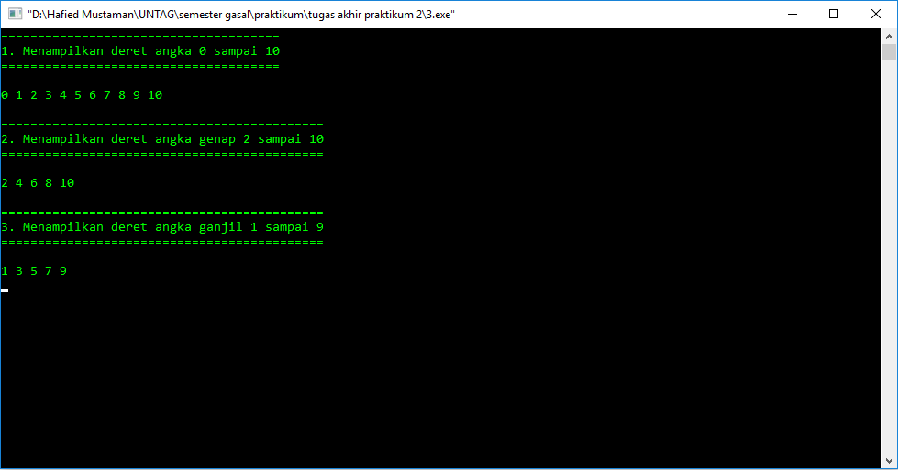

- Program dengan n diinput oleh user dan program bisa diulang sesuai keinginan user
/* program nomer 2 */
#include <iostream>
#include <conio.h>
using namespace std;
int main()
{
int bil=1, n;
cout<<"Masukkan nilai n: ";
cin>>n;
cout<<endl;
for(int i=0; i<n; i++)
{
bil=bil+i;
cout<<bil<<", ";
}
bil=1;
if(n<=0)
{
cout<<"ERROR!!!";
}
cout<<endl;
getch();
}
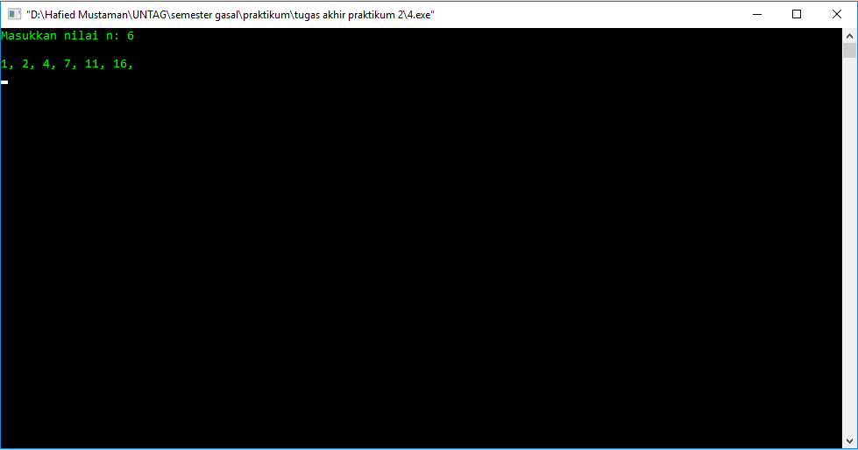

- Program dengan tinggi diinput oleh user
/* program nomer 3 */
#include <iostream>
#include <conio.h>
using namespace std;
int main()
{
int a, b, tinggi;
cout<<"Masukkan tinggi: ";
cin>>tinggi;
for(a=0; a<=tinggi; a++)
{
for(b=1; b<=a; b++)
{
cout<<(b+a)-1<<" ";
}
cout<<endl;
}
if(tinggi<=0)
{
cout<<"ERROR!!!";
}
cout<<endl;
getch();
}
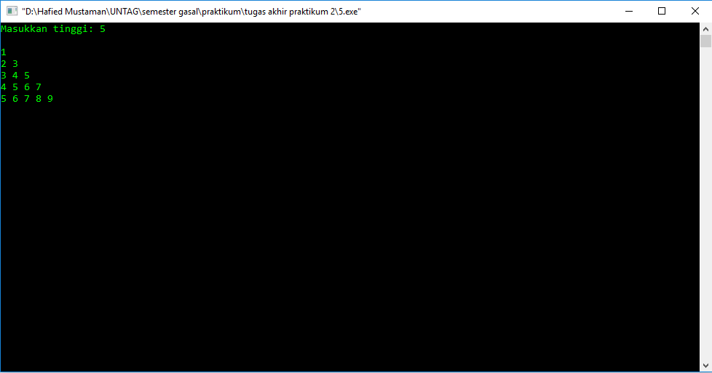

REVISI
2. Program dengan n diinput oleh user dan program bisa diulang sesuai keinginan user
/* program nomer 2 */
#include <iostream>
#include <conio.h>
using namespace std;
int main()
{
int bil=1, n;
char ulang;
do
{
cout<<"Masukkan nilai n: ";
cin>>n;
cout<<endl;
for(int i=0; i<n; i++)
{
bil=bil+i;
cout<<bil<<", ";
}
bil=1;
if(n<=0)
{
cout<<"ERROR!!!";
}
cout<<endl<<endl;
cout<<"Apakah anda ingin mengulangi lagi? (Y/N): ";
cin>>ulang;
cout<<endl;
}
while(ulang == 'Y');
getch();
return 0;
}
